

**LAB 8:**

**Remote Temperature Monitoring and Control**

**MCTA 3202**

GROUP F

GROUP MEMBERS MATRIC NO

1. Muhammad Naufal bin Mohammad Bakri 2110333
2. Muhammad Khairul Aiman bin Mohamad Basari 2113571
3. Muhammad Nabil Ikhmal Bin Khairil Rizal 2114577
4. Muhammad Zakwan Zikri bin Irwan Affandi 2111033
5. Che Muhammad Danial Bin Che Suhaimi 2119075

DATE OF SUBMISSION :

13rd December 2023

**Table of Contents**

**Abstract 2**

**Introduction 2**

Overview of the experiment's purpose and objectives. 2

Background information and relevant theory or concepts. 2

**Materials and Equipment 2**

**Methodology 4**

**Data Collection 4**

**Data Analysis 5**

**Results 7**

**Discussion 8**

**Conclusion 9**

**Recommendations 9**

**References 9**

**Appendices 10**

**Circuit Diagram 12**

**Student's Declaration 13**

## 

# **Abstract**

The ESP32 serves as the central processing unit, facilitating wireless communication through its built-in Wi-Fi capabilities. The DHT11 sensor accurately measures ambient temperature and humidity, providing critical environmental data for the system. A web-based interface allows users to access temperature information from anywhere with internet connectivity, enhancing convenience and accessibility.

# **Introduction**

## Overview of the experiment's purpose and objectives.

The objective of the experiment is to create a wireless temperature monitoring system using Wi-Fi, Arduino, and a temperature sensor or thermistor. The Arduino will read temperature data from the thermistor, send it to a Python script over Wi-Fi, and the Python script will display and log the temperature.

## Background information and relevant theory or concepts.

WIFI stands for Wireless Fidelity which is a wireless technology standard for wireless Internet access. It is used as a replacement for cable connections and other types of wires.The ESP32 can be configured to connect to an existing Wi-Fi network (station mode) or act as an access point for other devices to connect to it (soft access point mode).

Bluetooth is a wireless communication standard used for short-range communication between devices.In this experiment ESP32 serves as a Bluetooth server, sending data (temperature readings from the DHT11 sensor) to an Android device acting as a Bluetooth client.Bluetooth typically has a shorter range (tens of meters) compared to Wi-Fi, which can cover longer distances

# **Materials and Equipment**

1. Arduino board with Wi-Fi capability (ESP32)

2. Temperature sensor (DHT11)

3. Smartphone with Bluetooth support

4. Wi-Fi network and internet access

5. Power supply for the Arduino

6. Breadboard and jumper wires

**Experimental Setup**

Part A (WiFi)

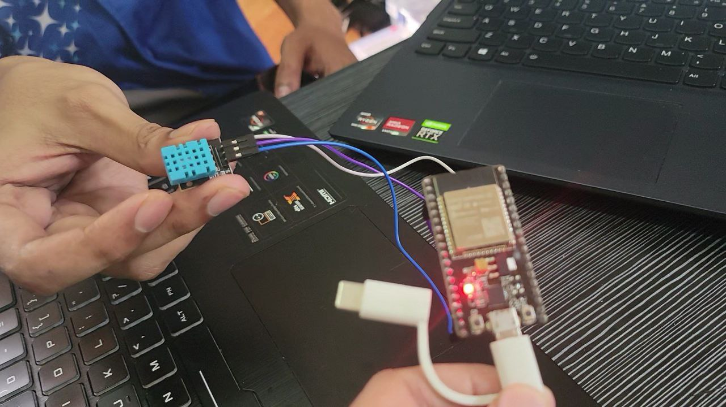

Part B (Bluetooth)

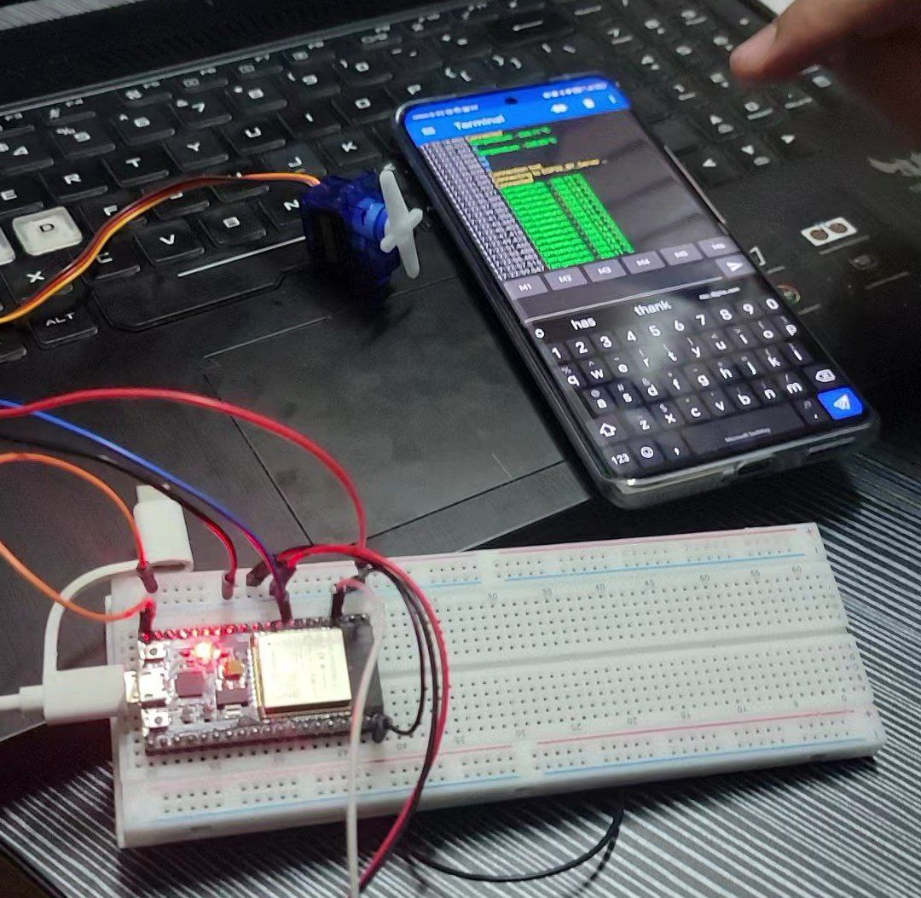

# **Methodology**

1. Hardware Setup:

• The temperature sensor (thermistor) is connected to the Arduino.

• The Bluetooth module is connected to the Arduino.

• The Arduino is connected to your Wi-Fi network using its built-in Wi-Fi capabilities.

2. Arduino Programming:

• An Arduino sketch is written that reads temperature data from the sensor.

• Wi-Fi connectivity is set up to enable the sending of temperature data to a cloud service like ThingSpeak, where a simple dashboard can be created to visualize the data.

3. Bluetooth Programming:

• An Arduino sketch is written to enable Bluetooth communication.

• The task below is completed.

4. Remote Monitoring:

• The ThingSpeak dashboard can be accessed on your computer or smartphone to remotely monitor the temperature in real-time via the internet.

# **Data Collection**

Part A (WiFi)

| CLOCK | ENTRY | TEMPERATURE (°C) |
| --- | --- | --- |
| 2023-12-11 07:28:59 UTC | 1 | 30.83 |
| 2023-12-11 07:29:25 UTC | 2 | 30.46 |
| 2023-12-11 07:29:51 UTC | 3 | 23.5 |
| 2023-12-11 07:30:44 UTC | 4 | 28.88 |
| 2023-12-11 07:31:22 UTC | 5 | 33.15 |
| 2023-12-11 07:32:14 UTC | 6 | 30.46 |
| 2023-12-11 07:32:29 UTC | 7 | 30.95 |
| 2023-12-11 07:32:44 UTC | 8 | 26.8 |
| 2023-12-11 07:32:59 UTC | 9 | 50 |
| 2023-12-11 07:33:15 UTC | 10 | 13 |
| 2023-12-11 07:33:30 UTC | 11 | 29 |
| 2023-12-11 07:33:45 UTC | 12 | 29 |
| 2023-12-11 07:34:02 UTC | 13 | 50 |
| 2023-12-11 07:34:18 UTC | 14 | 26.92 |
| 2023-12-11 07:34:38 UTC | 15 | 50 |
| 2023-12-11 07:34:54 UTC | 16 | 50 |
| 2023-12-11 07:35:09 UTC | 17 | 31.93 |

Part B (Bluetooth)

| TIME (s) | TEMPERATURE (°C) |
| --- | --- |
| 0 | -265.87 |
| 1 | -265.55 |
| 2 | -265.91 |
| 3 | -266.10 |
| 4 | -265.90 |
| 5 | -266.10 |
| 6 | -265.63 |
| 7 | -265.86 |

# **Data Analysis**

Part A (WiFi)

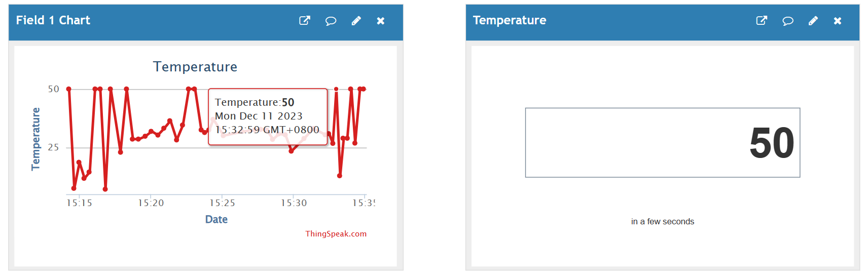

16th Entry (breathing at DHT11)

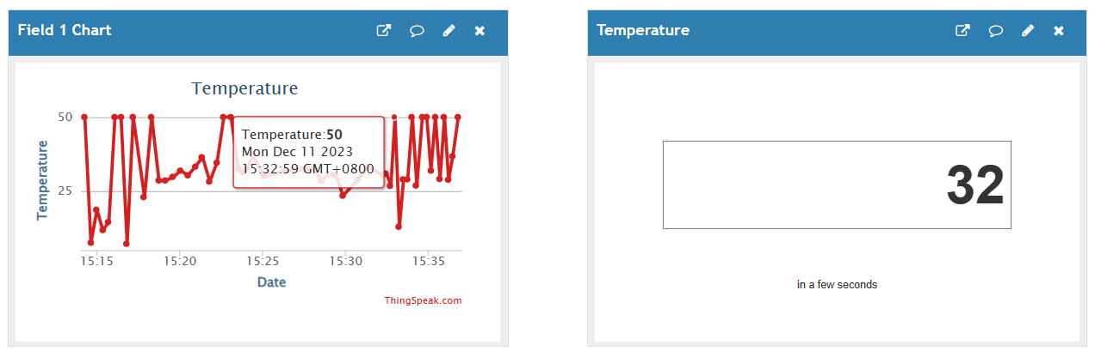

17th Entry (control)

Part B (Bluetooth)

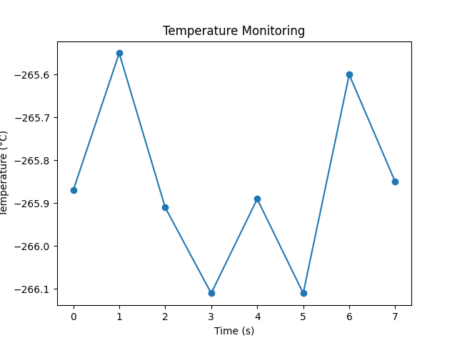

# 

# **Results**

Part A (WiFi)

# 

<https://github.com/NotLafuan/GROUP-F-MCTA-3203/raw/main/Week%208/GROUP%20F%20WEEK%208%201.mp4>

Part B (Bluetooth)

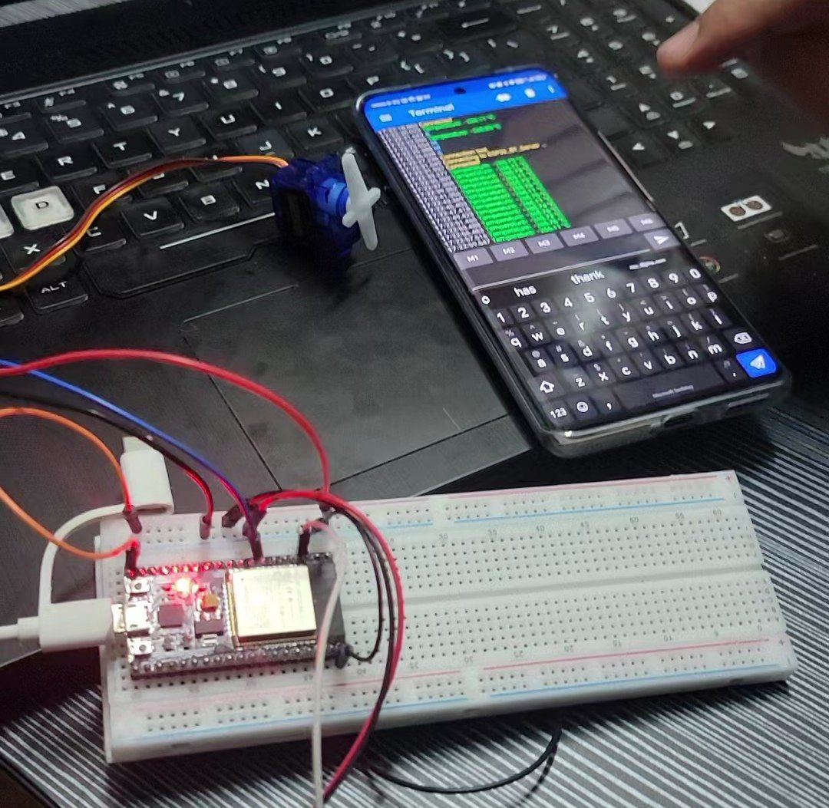

<https://github.com/NotLafuan/GROUP-F-MCTA-3203/raw/main/Week%208/GROUP%20F%20WEEK%208%202.mp4>

# **Discussion**

Throughout the experiment we can see that the Temperature sensor (DHT11), is sometimes giving inconsistent results and sometimes it is not as sensitive to temperature changes as it should be. The reason behind this is because we solely rely on raw calculation obtained from the voltage reading and consequently calculated by a formula. For better sensitivity, there should be a library provided with a proper transfer function in order to make the Temperature sensor more sensitive to surroundings.

While executing the experiment, we had to go through a hard time in setting up the Wifi Module (ESP32) as the wiring connection is pretty confusing as the connections and the code written in the Arduino IDE were not exactly as straightforward as they usually are. It has different pinout configurations for example, by connecting the pinout SVP/GPIO36 at the ESP32, then it will be written as pinout A0 in our Arduino coding.

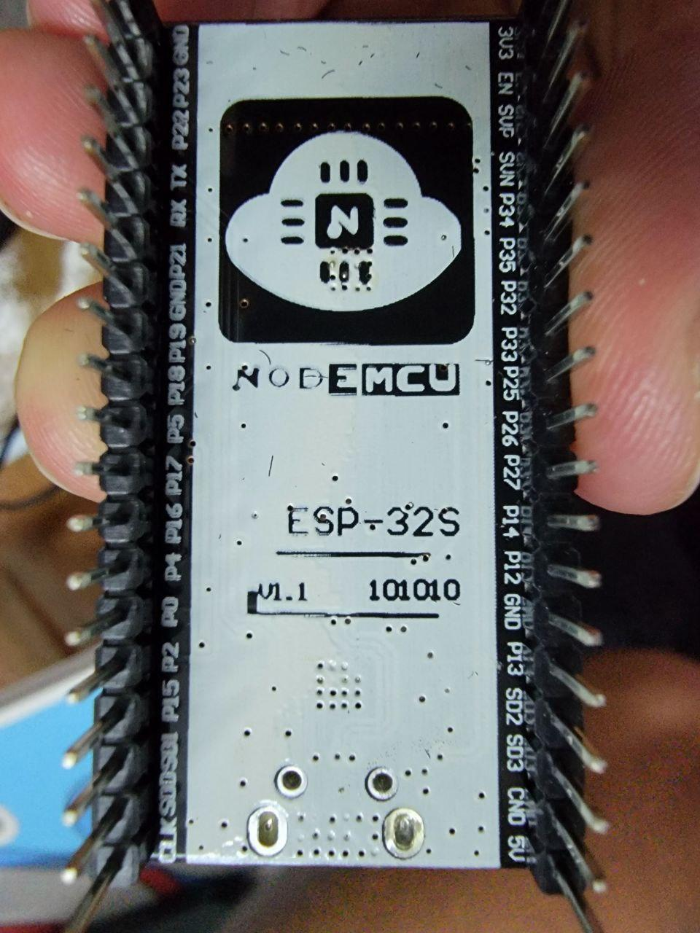

Other than that, while operating ThingSpeak we have identified quite a delay due to the OTA (Over-The-Air) updates which our devices software are operating remotely without the need for physical connection.

In order for the Bluetooth Module to work, it has to be utilized on an Android device because there has been no version of the Bluetooth module provided by the lab that is compatible for IOS devices.

While operating the experiment, we also had to take account the range limitations of Bluetooth and Wi-Fi radio-waves and to keep a close distance so that there wouldn't be any misreading and miscalculations due to loss of reach between the bluetooth device and our serial communication device.

# 

# **Conclusion**

In conclusion, we successfully implemented a system for real-time environmental monitoring using the ESP32 microcontroller, the DHT11 temperature and humidity sensor, Bluetooth and Wi-Fi communication. The project experiment on collecting accurate data from the sensor and transmitting it to an Android device for user-friendly display and analysis.

The implementation of Bluetooth and WiFi for the communication allow the user to to monitor environmental conditions in real-time and receive timely updates on temperature levels.

As the current implementation of IR 4.0 in the industry, features such as remote monitoring through cloud services, push notifications for critical conditions, and integration with home automation platforms can make possible by the implementation of Bluetooth and Wi-Fi.

# **Recommendations**

Since there is a delay in our experiment, to reduce OTA for higher efficiency, we can imply incremental updates which only change when there is new data compared to the old one, reducing the amount of data transmitted and improving speed.

Other than that , for the part B experiment that use the ESP32 as the wifi , the data that we get is not really accurate and maybe in the future we can try to improve the accuracy of ESP32 and DHT11 by focusing on the hardware, software, and calibration aspects of the system.For the DHT11, like any sensor, it may have slight variations between individual units. To improve it accuracy we will try to compare its readings with a calibrated reference sensor and apply correction factors if necessary.

# **References**

<https://www.youtube.com/watch?v=jYjuxWUefhg>

https://www.youtube.com/watch?v=dJJAQxyryoQ

# **Appendices**

#include <SoftwareSerial.h>

SoftwareSerial bluetooth(2, 3); // RX, TX

void setup() {

Serial.begin(9600); // Serial communication with the computer

bluetooth.begin(9600); // Serial communication with HC-05 module

Serial.println("Bluetooth Communication Ready");

}

void loop() {

// Read data from the computer and send it to HC-05

if (Serial.available() > 0) {

char data = Serial.read();

bluetooth.print(data);

}

// Read data from HC-05 and send it to the computer

if (bluetooth.available() > 0) {

char data = bluetooth.read();

Serial.print(data);

}

}

**Install SoftwareSerial Library:**

Open the Arduino IDE.

Go to "Sketch" > "Include Library" > "Manage Libraries..."

In the Library Manager, search for "SoftwareSerial" and click "Install" for the one by Paul Stoffregen.

Example of Arduino code for reading temperature from thermistor

const int analogPin = A0; // Analog pin for thermistor

const int resistorValue = 10; // Resistance connected to the thermistor

void setup() {

Serial.begin(9600);

}

void loop() {

int sensorValue = analogRead(analogPin);

double voltage = sensorValue * (5.0 / 1023.0); // Convert to voltage

// Use the Steinhart-Hart equation to convert voltage to temperature

double temperature = (1.0 / ((log(voltage / 5.0) / resistorValue) +

(1.0 / 298.15))) - 273.15;

// Send temperature data over serial

Serial.println(temperature);

delay(1000); // Delay for 1 second

}

**Python Side:**

import serial

import matplotlib.pyplot as plt

ser = serial.Serial('COMx', 9600)

temperatures = []

try:

while True:

data = ser.readline().decode('utf-8').strip()

temperature = float(data)

temperatures.append(temperature)

# Display real-time temperature

print(f"Temperature: {temperature} °C")

except KeyboardInterrupt:

# Plot the recorded temperatures when the user interrupts the script

plt.plot(temperatures, marker='o')

plt.title('Temperature Monitoring')

plt.xlabel('Time (s)')

plt.ylabel('Temperature (°C)')

plt.show()

finally:

ser.close()

# 

# 

# **Circuit Diagram**

Part A (Bluetooth)

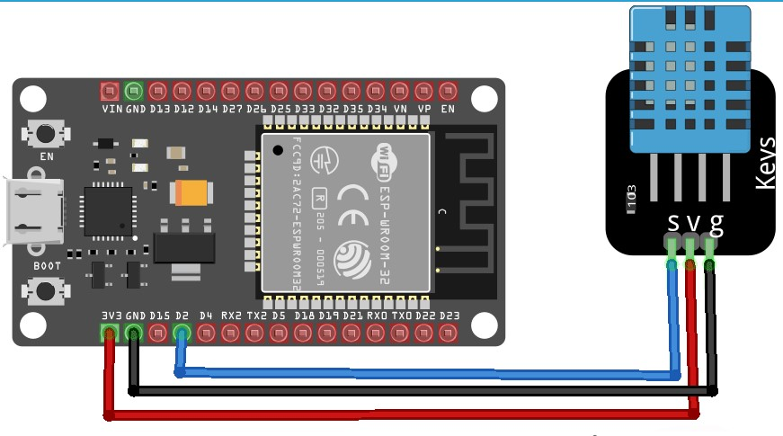

Part B (WiFi)

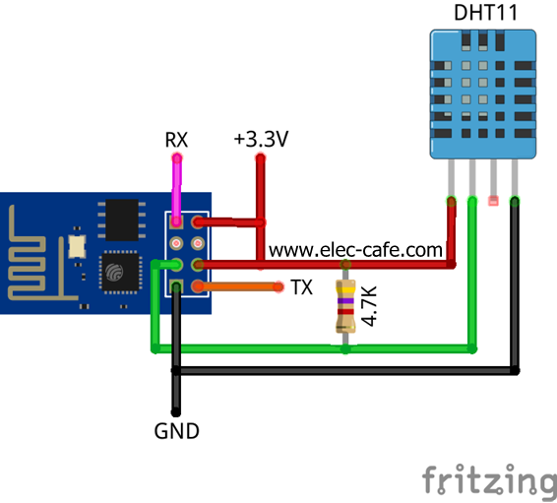

# **Student's Declaration**

**Certificate of Originality and Authenticity**

This is to certify that we are responsible for the work submitted in this report, that the original work is our own except as specified in the references and acknowledgement, and that the original work contained herein have not been untaken or done by unspecified sources or persons.

We hereby certify that this report has not been done by only one individual and all of us have contributed to the report. The length of contribution to the reports by each individual is noted within this certificate.

We also hereby certify that we have read and understand the content of the total report and no further improvement on the reports is needed from any of the individual’s contributors to the report.

We therefore, agreed unanimously that this report shall be submitted for marking and this final printed report has been verified by us.

Signature: Naufal Read

Name: Naufal Understand

Matric Number: 2110333 Agree

Contribution: Testing and Debugging

Signature: Aiman Read

Name: Aiman Understand

Matric Number: 2113571 Agree

Contribution : Programming

Signature: Nabil Read

Name: Nabil Understand

Matric Number: 2114577 Agree

Contribution: Circuit Design

Signature: Zakwan Read

Name: Zakwan Understand

Matric Number: 2111033 Agree

Contribution: Data Analysis

Signature: Che Read

Name: Che Understand

Matric Number: 21119075 Agree

Contribution : Discussion